**Matthew Austin**

**Assignment 5**

**CIS356** – Spring Term 2018

**Point Value**: 100 points

**Assignment Due Date**: **In class Thursday, April 6, 2018**

**Submission Instruction**

Please submit your assignment 5 to your instructor in class on the due date and submit your hw5_lastname_firstname.pdf or .docx on Schoology. You need to write down your entire procedure including every command you use for creating new users. For some of the tasks, you can write a ***shell script*** to do them. This is not required. If you write your own script, please attach it at the end of this assignment. Finally, you need to show the instructor that you successfully created these users and their directories on your Ubuntu server.

**Description of creating new users**

1. You have received a new batch of distinguished users; their basic information is located in newusers.txt on Schoology. This file contains a colon-separated entry for each user: the username, the uid, the GECOS information, and the user's preferred shell.
2. Please add these users to your Ubuntu machine as local users (you might verify that no name clashes occur before you proceed!). Create home directories on your Ubuntu server with the usual files from /etc/skel (.bash_logout, .bashrc, .profile), but put the home directories in /home/users/USERNAME/, not just /home/USERNAME. Each user should have his own group, where the group id matches the user id. Assign a password to each of these accounts. Try to use the “su USERNAME” command to verify that each user has the right permissions and owns appropriate directory(s). (50 points)

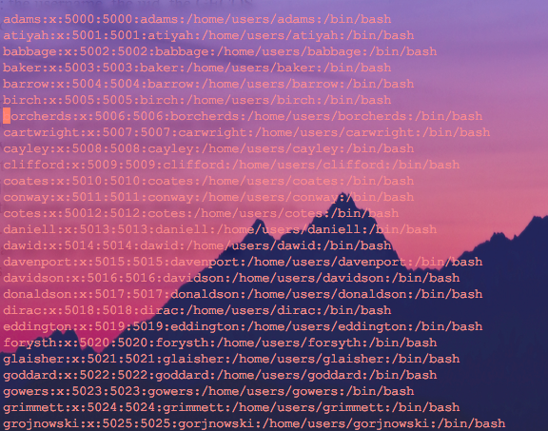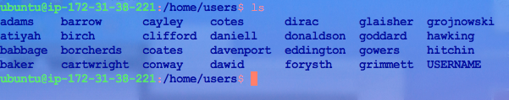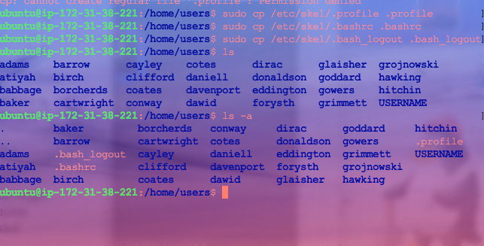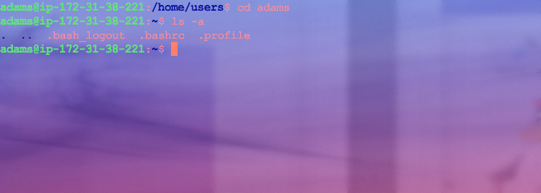

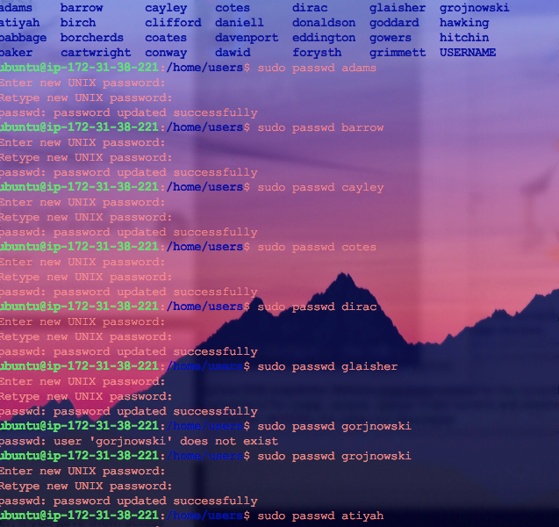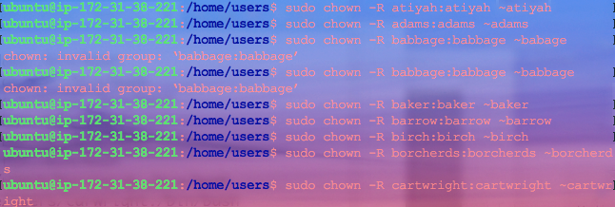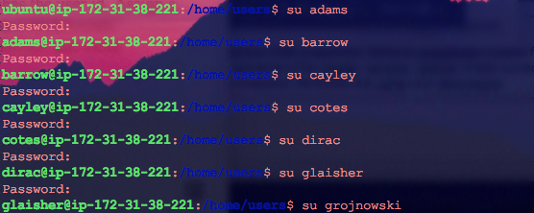

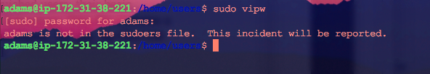



1. Similar to the step 2, please add a new user named “myadmin”. Besides, add this user to the /etc/sudoer file and make sure that this user has root privilege, so this user can use “*sudo”*. Try to use the “su myadmin” command to verify that this user can log in and run some commands which requires root privilege such as $sudo less /etc/shadow. (25 points)

commands used:

sudo useradd myadmin

sudo passwd myadmin

sudo usermod -aG sudo myadmin

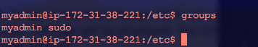

1. Create a /CIS356/USERNAME/ directory for each user, and make sure that it is owned by the correct user and has the correct group number. (25 points)

commands used:

I su’d into every user and used the commands manually:

mkdir CIS356

cd CIS356

mkdir USERNAME

used command groups

